Friends of
Patteson LodgeNewsletter
February 2026

The Friends committee meets to discuss future events and hear about future fundraising projects for the Centre. We have some new committee members, so look out for some different menus!

The outdoor camp kitchen framework has been installed on the campsite.

Fundraising purchase in 2025:

It was time to buy a new large upright frost-free freezer for the Lodge:

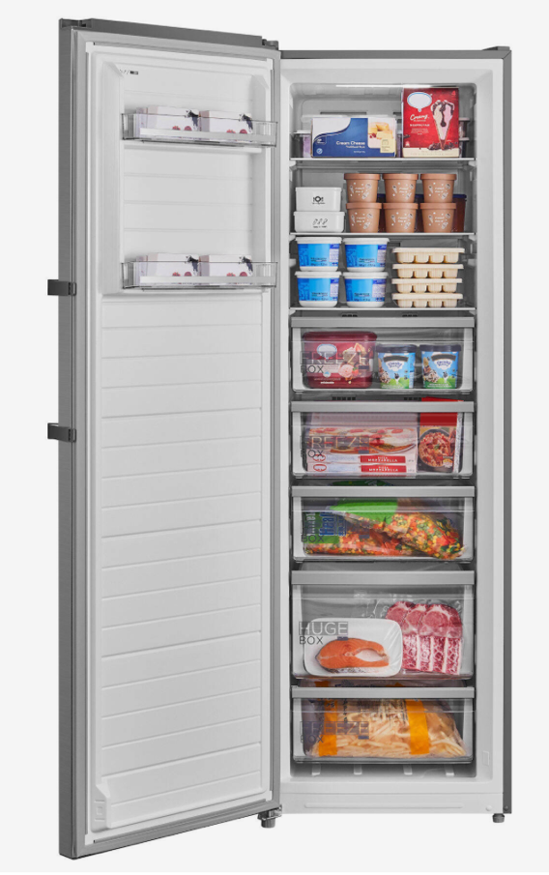

Here are the next fundraising events with some revised dates to update your diaries!

- Annual Lunch on
Wednesday 22 April 2026
1pm to 4pm


- Afternoon Tea on Wednesday 21 October 2026 from 2pm to 4pm.

The AGM will be on Wednesday 18 March 2026 at 2.30pm – all welcome!

Committee Updates:

We are delighted to say that Val found some willing helpers with great catering skills: Mags Buxton, Debbie Wright and Carole Smith all join the committee at the next AGM! Thanks to Gill, Pat, Judy and Sheila who have hung up their aprons after many successful fundraisers.

Contacts

Chairman-Val Purdy (01603) 897299
Email Val@pur7dy.plus.com

Vice Chair & Treasurer – Sheila Ford
Email: winnie1stnw@gmail.com

Secretary – Sue Edes
Email: friendsofpl@btinternet.com

We always welcome new Friends, so if you know of someone, or a group, who’d like to join Friends of Patteson Lodge, here’s the information they need! 2026 Membership is £5 for individuals and £15 for groups.
Membership Form

