


Welcome to Patteson Lodge

We hope you enjoy your stay with us. This folder should contain any information you need. If you have any problems please contact a member of staff who will be happy to help you.
On Arrival
- Turn on hot water in the kitchen (above the hand basin), and turn on the water boiler if needed.
- Ensure you are familiar with how to lock the doors at night and how to secure the building when you leave - including how the alarm system works.
- Carry out a fire drill as soon as possible after your group arrives, and log the details in the folder hanging beneath the fire bell at the bottom of the stairs.
- If the building is cold, turn the thermostats up, and the heating will kick in on a timer.
On Departure
- Ensure all furniture is left where it was on arrival.
- Clean the building thoroughly before leaving.
- Turn off the hot water and water boiler in the kitchen.
- Leave cash tin, keys, and feedback form on coffee table in cosy corner
- Turn off all lights, ensure the corridor light has been turned off night mode. Turn thermostats back down as low as they will go.
- Close all windows and all hall blinds. Check external doors are all closed and locked.
- Finally, lock the front door, and return the key to keysafe.
Thank you
Jan 2025
Patteson Lodge Activity Centre
14 Great Hautbois Road
Coltishall, Norwich
Norfolk, NR12 7JN
Office: 01603 737996
Email: pl@girlguidingnorfolk.org.uk

Emergency contact numbers
In an emergency, dial 999
What3words reference ///bogus.unity.limits

Local GP Surgery
Coltishall Surgery, 3 St John’s Close,
Coltishall, NR12 7HA 01603 737593

NHS Direct
Can give medical advice if
you are not sure what to do 111

Norwich Walk-in Centre
Rouen Road, Norwich, NR1 1RB
7am-9pm Mon-Sun 01603 677500

Norfolk and Norwich Hospital
Colney Lane, Norwich, NR4 7UY
24 hour A&E department 01603 286286

Cromer Minor Injuries Unit
Mill Road, Cromer, NR27 0BQ 8am -7.45pm Mon-Sun
(via N&N Switchboard) 01603 286286
Non-emergency Police Number 101
Patteson Lodge Activity Centre
14 Great Hautbois Road
Coltishall, Norwich
Norfolk, NR12 7JN
Office: 01603 737996
Email: pl@girlguidingnorfolk.org.uk

Useful Contact Numbers
If you need help during your stay, please contact staff via
01603 737996
This number will divert to the duty mobile phone

Hautbois Shop
Mon-Thur 10-5
Sat - 10-4 01603 739694

What to do in the case of an accident or incident
If there's been an accident or incident, these are the first things you need to do:
- Keep calm. The most important thing is that you don't panic and you think clearly.
- Make sure, as far as you can, that the girls and young women you're taking care of, and the other volunteers with you, are safe.
- Call the emergency services if appropriate.
What to do in a serious emergency
In case of a serious emergency you must then do the following:
- If outside your guiding area, tell your home contact what has happened.
- Call your commissioner to tell them exactly what happened and together decide what to do next.
- Call our insurance team on 0845 260 1053 during office hours if it's a serious incident. If it's out of hours, please call the emergency PR line on 020 7592 1891 or get in touch with the insurance department on the next working day.
- If it's related to a safeguarding issue, please call the safeguarding team on 0207 834 6242 ext. 3037 or the out of hours phone on 07508 032997. The out-of-hours phone line is for emergencies only, and is in operation 5pm-10pm Monday-Friday and 9am-10pm Saturday and Sunday.
- Don't say that you were responsible or admit liability.
- Get witnesses' names and contact details.
Keep careful notes about the incident and developments as they happen, including dates, times and names. Keep copies of any written information, including letters, forms or reports. Please send these documents with a notification of accident or incident form.

Your commissioner is there to support you. Together you should decide what action is needed, for example:
- Provide support for those involved.
- Contact your home contact and establish them as a central point where people can send enquiries, facts can be updated and so on. Alternatively, set up a central point to undertake this role.
- Contact your local area's public relations adviser, and ask them to communicate with the relevant parties such as the local community and the media.
- Compile a confidential report.
- Provide support resources, such as helplines or extra people.
In the event of a serious accident or death, Girlguiding must be contacted immediately via the emergency PR line on 020 7592 1733 or the out-of-office hours PR line on 020 7592 1891.
If contacted by the press
Don't make comments to them straightaway. Instead, take their name and contact details, ask for a deadline and tell them that someone will get back to them. You can then pass this on to Girlguiding's PR team.
What happens after reporting an accident or incident
You'll receive a notification from GO to confirm that the insurance team has received your notification of accident or incident form. They’ll advise you about the next steps to take.
The insurance department will also send an acknowledgment letter to the injured person (or their next of kin if they're under 18). If the injured person needed further medical treatment, they're entitled to apply to the members’ benefit scheme, a discretionary fund members can claim against, to recover some of the expenses they might have incurred relating to an accident or incident during guiding activities. The insurance department will send them details of how to apply to this scheme.

Following an incident, you must not admit liability at any time. Before taking any major remedial action following an incident, such as doing repair work to Girlguiding properties, you need to get agreement from Girlguiding's insurance department.
You should send any correspondence you receive about an incident to the insurance department – especially legal letters. Girlguiding has insurance to cover you against claims for accidents but you need to share the legal letter with the insurance department within 24 hours so that we can comply with the law. You don't need to reply to the correspondence yourself and no offer of money should be made at any time.
The insurance team will be in touch with you about what's happening once they've received and acknowledged it.
Girlguiding takes safety very seriously and the insurance department monitors all accidents and incidents recorded during guiding activities. This helps us to make informed decisions about future training and support.

Patteson Lodge Activity Centre
14 Great Hautbois Road
Coltishall, Norwich
Norfolk, NR12 7JN
Office: 01603 737996
Email: pl@girlguidingnorfolk.org.uk

Central heating and hot water

The heating and hot water will be pre-set for your visit and are set on a timer. They will come on twice a day (morning and evening) subject to the thermostats being turned up.
Should you need to boost the heating or hot water, you can press the boost button on the wall which will override the timer and give an extra hour of heating.
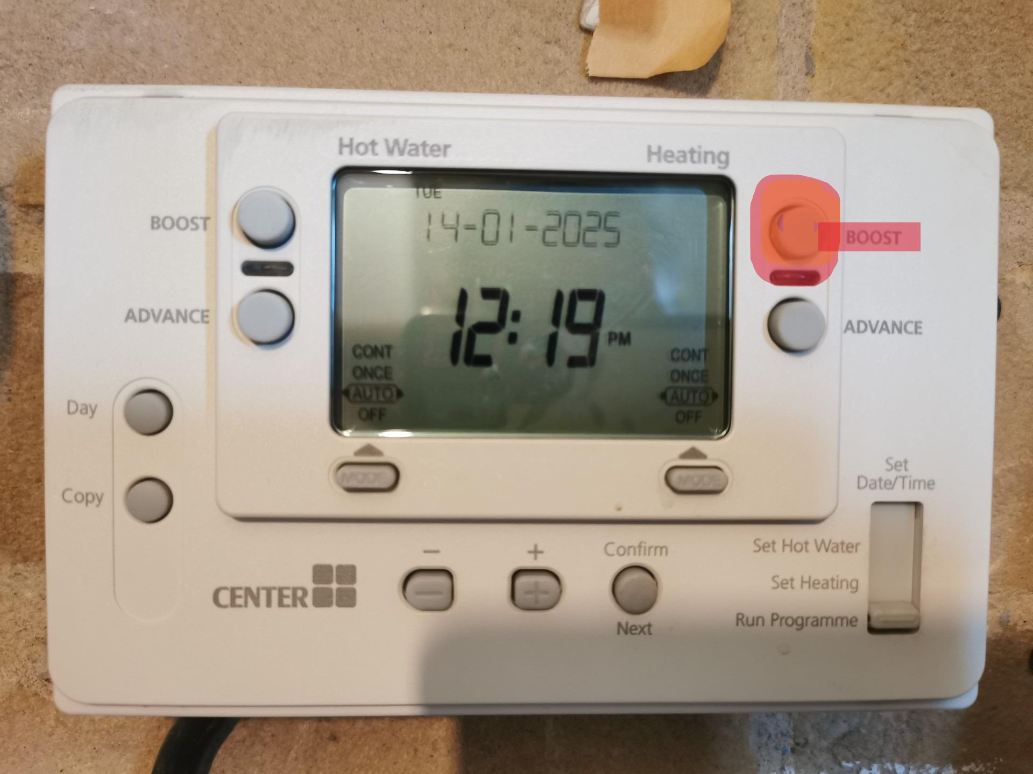

Patteson Lodge Activity Centre
14 Great Hautbois Road
Coltishall, Norwich
Norfolk, NR12 7JN
Office: 01603 737996
Email: pl@girlguidingnorfolk.org.uk

Rubbish and Recycling.
All bins should be emptied on your departure - and placed into the correct bin on the driveway. There is a bin for refuse, and a bin for recycling.
What can I put in the Recycling bin?
- Paper and cardboard
- All types of magazines and catalogues
- Clean wrapping paper (without sellotape)
- Rinsed food and drink can
- Empty aerosol cans
- Clean, empty, plastic bottles.
- Clean plastic food pots, tubs & trays inc. yoghurt pots, margarine tubs ect.
- Clean glass bottles and jars
- Food and drink cartons
- Aluminium foil and trays
- Shredded paper and envelopes

Patteson Lodge Activity Centre
14 Great Hautbois Road
Coltishall, Norwich
Norfolk, NR12 7JN
Office: 01603 737996
Email: pl@girlguidingnorfolk.org.uk
Lighting

In order to save energy, some of our lights are automatic, and will come on when they detect motion.
Currently, the following lights are automatic:
- Entrance hall
- Landing
- Main washroom and toilets
- Upstairs toilet
- Freezer cupboard
- Main corridor.

The main corridor has a ‘day/night’ switch, which will override the automatic sensor, and instead put a ‘nightlight’ on solidly. This is useful to use overnight to help people navigate to the washroom.

Patteson Lodge Activity Centre
14 Great Hautbois Road
Coltishall, Norwich
Norfolk, NR12 7JN
Office: 01603 737996
Email: pl@girlguidingnorfolk.org.uk
Internet Connection

Patteson lodge has Wi-Fi internet available for you to use.

Wi-Fi Name: BTB-2ZF2ZG-Guest

Wi-Fi Password: Patteson1982

Please ensure you adhere to Girlguiding Online Safety Guidelines, or the relevant guidelines for your organisation.

Patteson Lodge Activity Centre
14 Great Hautbois Road
Coltishall, Norwich
Norfolk, NR12 7JN
Office: 01603 737996
Email: pl@girlguidingnorfolk.org.uk

Patteson Lodge Shop

The shop is situated on the upstairs landing, and can be accessed at a time convenient to you during your stay. Adult supervision is required, and all monies should be placed into the cash tin, the key for which is on the main keyring.
All items should be clearly priced, but a stock and price list can also be found in the cash tin. Please remember to update the stock list with the items sold and the total cash amount for your visit.

Patteson Lodge Activity Centre
14 Great Hautbois Road
Coltishall, Norwich
Norfolk, NR12 7JN
Office: 01603 737996
Email: pl@girlguidingnorfolk.org.uk

Friends of Patteson Lodge

- Have you enjoyed a stay at Patteson Lodge?
- Would you like to join us to help raise additional funds for future improvement of the facilities?
- Are you already a member of the Friends of Patteson Lodge?

If not, why not join us? Individual and group memberships are available.
Please fill in a subscription form, or contact the administrator for more details.

Patteson Lodge Activity Centre
14 Great Hautbois Road
Coltishall, Norwich
Norfolk, NR12 7JN
Office: 01603 737996
Email: pl@girlguidingnorfolk.org.uk

Fire Procedure/Plan
All groups are required to perform a fire drill as soon as practical after arrival, and record these in the fire drill log book.
Evacuation Procedures:
Upon the discovery of a fire, young people should alert an adult, who should then activate the fire alarm by breaking one of the break-glasses.
- Main Corridor
- Entrance Hall
- Main Hall
- Kitchen
- Indaba Room
In case of a real fire, dial 999.
- Ensure all persons have left the building - check all rooms to ensure nobody is left behind.
- Collect the roll call lists of all people present in the building from your exit point.
- Close all doors behind you as you evacuate.
- Ensure anyone with difficulties is assisted in exiting the building.
- Assemble at the HMS Patteson boat (on the lawn to the roadside of the building) and perform a register to verify everyone has left the building.
- We are on RED CARE system, so the Fire Service and emergency key holders should already be made aware of the alarm, but you should still dial 999 to provide updated information.
- Whilst everyone else remains at the muster point, an adult in charge should remain at the entrance to liaise with the Fire Service.
- Do not re-enter the building until advised it is safe to do so by the Fire Service.

All groups are responsible for familiarising themselves with the location of ALL fire escapes.
The fire alarm is tested weekly, and is maintained by Dragon Security, Wroxham, 01603 783958.

Patteson Lodge Activity Centre
14 Great Hautbois Road
Coltishall, Norwich
Norfolk, NR12 7JN
Office: 01603 737996
Email: pl@girlguidingnorfolk.org.uk

Welcome Checklist

Welcome to Patteson Lodge! Before you settle in, please familiarise yourselves with the contents of this folder, and ensure the following:

- Have you received the keys?
- Are you familiar with the door locks and codes?
- Have you been given the cash box if you wish to use the shop?
- Have you received your invoice and paid for the correct number of people on your booking?
- Have you completed, or plan to complete a fire drill?

If you have any questions about any of the above, please contact a member of staff.

We hope you enjoy your stay!

Patteson Lodge Activity Centre
14 Great Hautbois Road
Coltishall, Norwich
Norfolk, NR12 7JN
Office: 01603 737996
Email: pl@girlguidingnorfolk.org.uk

Departure Checklist
Please ensure the following tasks are completed before you depart.
Kitchen
- Fridge - ensure it is left empty and clean
- Cooker - clean the hob and inside of any food spills
- Dishwasher - ensure left empty, and any food debris emptied.
- Bins - Empty all bins - place rubbish into the correct outside bin.
- Worktops & sink - Wipe down with warm soapy water
- Check all appliances are off, and hot water is turned off (unless instructed otherwise)
- Check all doors are locked.
Main Hall
- Tidy and vacuum the carpeted area.
- Replace all tables into cupboard, and stack chairs to the sides
- Check all external doors and windows are closed and locked.
- Sweep floor and close blinds
Dormitories and bedrooms
- Leave any Patteson Lodge bedding neatly on each bed.
- Empty waste paper bins
- Vacuum floors
- Check windows are closed, and close curtains.
Washrooms
- Clean showers, sinks, and toilets.
- Empty Bins
- Sweep Floor.

Please leave the keys and cash tin on the coffee table, and ensure the door is correctly locked.
Patteson Lodge Activity Centre
14 Great Hautbois Road
Coltishall, Norwich
Norfolk, NR12 7JN
Office: 01603 737996
Email: pl@girlguidingnorfolk.org.uk

Dishwasher Instructions
Turn on the main switch - LARGE RED KNOB on the wall above the dishwasher. Press ON button on the machine. When the green light stops flashing it is ready to use. This can take up to 30 mins.
To Use:
1) Rinse dirty items and place them into the washing rack Put the rack into the machine and close the door.
2) Press button for the desired programme - (1) for short or (2) for standard.
3) The LED light will flash during the programme. Once it stops flashing, the programme is complete.
4) Open the door and take out the rack - allow dishes to dry in the rack before putting them away. Continue to use until your dishes are complete.
Programme 1 - Glasses and Drinkware - 2 minutes
Programme 2 - Plates, dishes, cutlery, or mixed - 3.5 minutes.

After each use:
1) Empty the machine and close the door.
2) Push and hold (min. 3 seconds) the DRAIN button.
3) The machine will drain and the green light will flash.
4) When it is finished, it will turn itself off, switch off the main wall switch
5) Remove the strainers and filter (pull up) to remove food residue, and rinse under the tap. Replace the filter and strainers.
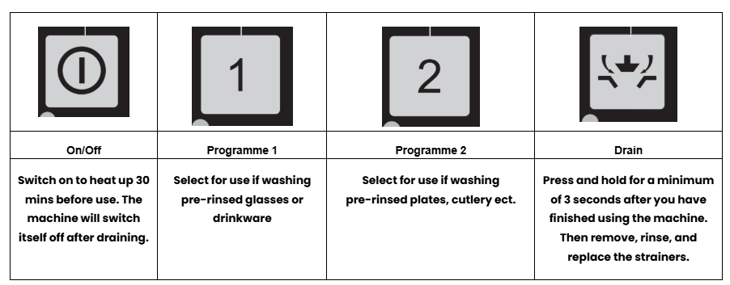
Safe use of dishwasher:
Only to be loaded/unloaded by an adult due to weight of racks. Please be aware of hazard warnings on detergent bottles
Patteson Lodge Activity Centre
14 Great Hautbois Road
Coltishall, Norwich
Norfolk, NR12 7JN
Office: 01603 737996
Email: pl@girlguidingnorfolk.org.uk

Oven Instructions
Oven Lighting
- Turn the FUSE switch on (right hand side of the cooker)
- Turn key to ON (ensure the fan switch is at 3 minimum)
- Open the oven doors, and turn the oven temp knob up and hold in.
- Press the oven igniter knob (black button in the bottom centre of the oven).
- Once the burner is alight, continue to HOLD the thermostat for a further 10 seconds, and then release.
If the burner goes out, repeat the steps from the beginning.
- Close the oven doors, adjust the oven temp. to your desired level, and allow the oven to pre-heat.
- Begin cooking.
Hob Lighting
- Turn the appropriate knob and hold.
- Light burner using either a flame or spark clicker.
- Continue to hold the knob for 10 seconds.

If gas flow is stopped due to the fan, turn key off and then on again.
To Turn OFF - Turn all oven knobs to off, turn the key to off, and turn fuse switch off.
If it is windy and gas cuts out, turn the fan key up beyond 3.

Patteson Lodge Activity Centre
14 Great Hautbois Road
Coltishall, Norwich
Norfolk, NR12 7JN
Office: 01603 737996
Email: pl@girlguidingnorfolk.org.uk
Kitchen Health and Hygiene

Due to Health and Safety Regulations, it is recommended that a daily diary be kept to ensure that proper health and hygiene processes are being followed.

Daily opening and closing checks should be completed and recorded in the Kitchen Diary (Located in the Kitchen information Folder.)
This folder also has more kitchen specific information, and should be read by anyone responsible for catering during your stay.

Patteson Lodge Activity Centre
14 Great Hautbois Road
Coltishall, Norwich
Norfolk, NR12 7JN
Office: 01603 737996
Email: pl@girlguidingnorfolk.org.uk

Kitchen Information Folder

This folder contains all the instructions you will need for the various kitchen appliances. Please read through and familiarise yourself with the information given before you begin using the kitchen.
On arrival, you should check the hot water is on. This is the switch on the wall above the dishwasher.
You should also check if the Lincat boiler has been turned on (should you require it) this will give you access to instant hot water negating the need to boil a kettle.

The person in charge of catering should ensure that daily opening and closing checks are completed, and recorded in the Dairy section of this file.
Please make sure any feedback from the kitchen checks is passed on and included in the overall feedback given at the end of your stay.

Patteson Lodge Activity Centre
14 Great Hautbois Road
Coltishall, Norwich
Norfolk, NR12 7JN
Office: 01603 737996
Email: pl@girlguidingnorfolk.org.uk

Kitchen Daily Checks
Opening Checks
- Fridges/Freezers are working, and at correct temperatures.
- Oven is working properly
- Staff are fit and wearing suitable clothes.
- Food preparation surfaces and equipment are clean.
- There are sufficient hand washing and cleaning provisions.
- There is a kitchen First Aid kit available, and a First Aid process in place.
- Any allergies have been notified to the kitchen and catered for accordingly.

Closing Checks
- No food is left out
- Expired food has been correctly disposed of.
- Dirty cleaning cloths have been removed and replaced with clean ones.
- Waste has been removed, and new bags put into the bins.
- Surfaces and equipment have been cleaned.

Completion of these checkers should be recorded in the diary, and initialled by the person responsible for catering.

Patteson Lodge Activity Centre
14 Great Hautbois Road
Coltishall, Norwich
Norfolk, NR12 7JN
Office: 01603 737996
Email: pl@girlguidingnorfolk.org.uk

Information Folder Index
Adults in charge should familiarise themselves with the information in this folder at the beginning of their stay.

- Welcome checklist
- Departure checklist
- Useful contact numbers
- Fire procedure/plan
- Alarm zone chart/Fire safety equipment locations
- Emergency numbers
- What to do in case of an accident/incident (GGUK guidelines)
- Central heating/hot water
- Internet connection
- LIghting
- Rubbish and recycling
- Patteson Lodge shop
- Friends of Patteson Lodge
- Kitchen health and hygiene
- Oven instructions
- Dishwasher instructions
- Mosaic trail information

